Practice 3

**P24**.

Host A and B are communicating over a TCP connection, and Host B has already received from A all bytes up through byte 248.

The first and second segments contain 40 and 60 bytes of data, respectively.

The first segment of sequence number is 249.

The source port number is 503.

The destination port number is 80.

1. Sequence number = first segment of sequence number + destination port number

= 249 + 80 = 329

Source port number = 503.

Destination port number = 80.

1. Acknowledgement number = 329

Source port number = 80.

Destination port number = 503.

1. If the second segment arrives before the first segment, in the acknowledgement of the first arriving segment, the acknowledgement number will be 249, indicating that it is still waiting for bytes 249 and onwards.

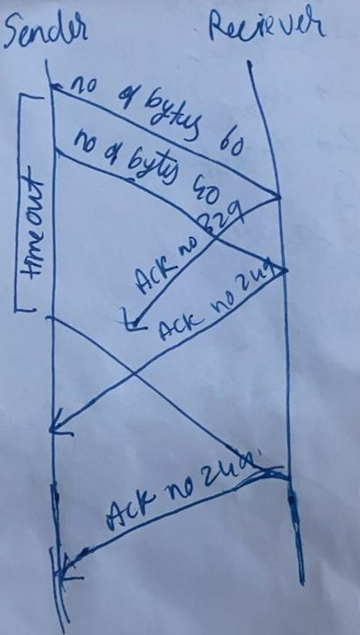

**P25**.

The effect of TCP flow control: If the host A faster than host B sending data then buffer fill up is start. If the buffer filled completely then send data from host B to host A until the remove buffer data and intimate to continue sending data or not. Then again filled buffer then repeat the process from host A to host B.

**P33.**

1. If TCP slow start is operating, then the intervals of time 1 to 6 and 23 to 26.
2. If TCP congestion avoidance is operating, then the intervals of time 6 to 23.
3. After the 16th transmission round, then the segment loss detected by a triple duplicate ACK.
4. After the 22nd transmission round, then the segment loss detected by timeout.
5. The initial value of threshold at the first transmission round 32.
6. The value of threshold at the 18th transmission round 21.
7. The value of threshold at the 24th transmission round 13.
8. The transmission round is the 70th segment sent is 7.
9. If a packet loss is detected after the 26th round by the receipt of a triple duplicate ACK, then the value is 4.